**A min to D7#5**

1. 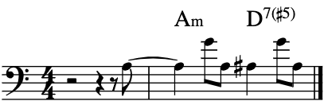
2. 